The ZL2BMI extra simple DSB 80m Transceiver
Dec 2010
Back in the mid 1980’s, in order to have a very small rig for tramping (bushwalking or hiking), for up to 7-day trips in remote areas of New Zealand, I designed and built various 80m DSB transceivers. Some of these were initially published in the NZART magazine; “Break-In”; (1984 & 1986) and shortly afterwards I produced a booklet giving some details, which were sold through “SPRAT” around the world.
Subsequently this booklet was published as an article in SPRAT 83.

In the intervening years I have continued to use a very small (100gm) version of this radio, but did not have the time or incentive to improve it, partly because of another interest in micro-hydro and renewable energy.

In the last few years, as I have had more time for tramping, a good number of my friends have seen the rig and have done their amateur license so that they could use one on tramping trips also. However, reproducing the original was quite difficult (see the original article), particularly as the VFO was so small. So I began to look for a simpler way to produce something using the ubiquitous NE602, and dispensing with the vfo as a separate unit.

No-where on my searches of the internet had I ever seen anyone use the two mixers of the 602 as both transmit and receive at the same time, but I didn’t see why it should not be possible. Having an inbuilt oscillator, I figured it should be possible to use that as the tuning, especially since ceramic resonators were now available – which either didn’t exist or were not available in the mid 1980’s.

By continuing to use a carbon microphone, I was able to get plenty of audio to drive one of the mixers in the NE602 as a balanced modulator, and used the other mixer for the receiver. Attempts to use the oscillator as a VFO were unsuccessful because of insufficient buffering within the 602, leading to severe fm-ing. However, with a ceramic resonator, as long as the frequency elements were shielded, the DSB was quite acceptable. Naturally a crystal works very well (even without shielding).

In addition, the circuits published in SPRAT in the last few years about getting further gain from an LM386 enabled it to be used (combined with the mixer gain from the 602), to drive a small speaker (27mm).

So the final line-up is just two i/cs and two transistors. The output is about 1.5 watts PEP and the sensitivity has been measured at about 1 - 2uV.

Basically the NE602/612 runs all the time, and there is no muting of the receive input – it just remains connected.
Likewise, the mic remains connected, though the +ve supply to the mic. is switched.
The audio amp (LM386) supply is switched as is the supply to the RF amp board (which is basically the same as in the earlier versions of ZL2BMI transceivers). However, because the output of the NE602 is high impedance (about 1500 ohms), a small ferrite transformer is used for impedance matching to the RF amp.
I tried driving the amp directly but the output was poor. However, I showed the rig to Peter Parker (VK3YE) while in Melbourne a few months ago, and he produced a 40m version within a short time which seems to work ok without the need for this transformer.

I did use an electret mic to directly replace the carbon mic and had reports of excellent signals (5/7) from a station about 800km away, though it did not appear to me that I was putting our more than about half a watt.

I still do not use a filter on the output, partially because there are seldom any problems with such low power in remote areas of the bush, but also because there seem to be far fewer harmonics with the oscillator of the NE602 than I ever had with external oscillators. But I suggest using the standard pi-net if used in town.

The circuit is built in a kind of “neat” ugly-bug construction, and there are at least 5 of these now built, three by myself and two by Bob ZL2ASO. A number of others are at present under construction.
(Since the above was written – Phil ZL2NJ has drawn up a pc board. He etched it, dropped in the components and apparently it went “first time”. However, the aerial input coil and the interstage transformer used are more standard components, though you could still use the same as the original. The pc board and partial overlay are attached.)

So here is the circuit with some explanations –
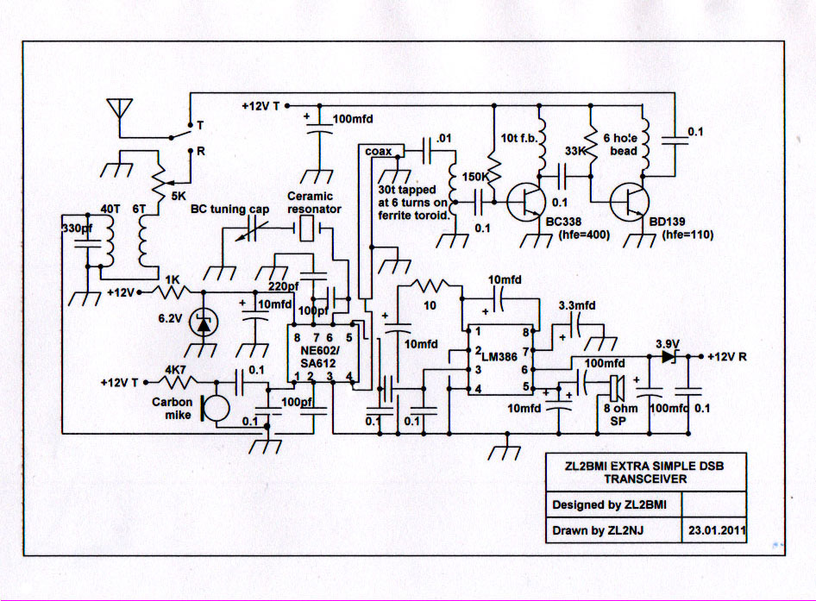

Notes –
1. Input receive coil wound on 5mm former (slug-tuned). Two earthed pins soldered to front panel for support.
2. NE602 voltage could be increased to about 7volts for a bit more drive.
3. Carbon mic – I intend to fit an electret with inbuilt 1-transistor amp in place eventually (or see Sprat 83).
4. Ceramic resonator in indicative only. Often there are multiple resonators and crystals switched in the “osc” box. It depends on what the user needs.
5. There are probably better ways of getting more gain from the LM386 with less distortion, but this worked. The 10uf cap on pin 5 to ground was to prevent oscillations. The unconventional “voltage dropper” (3.9v zener) meant that power was not wasted in a resistor. However, a 3-terminal regulator may be better.
6. The impedance transformer for the input to the rf amp seemed to work with almost any small ferrite core – I suspect that even a bead could be used with fine wire. I measured the Hfe of the transistors so that I did not need to keep adjusting the bias resistors for each new rig. If you use “hotter” transistors, you will need to check that the standing current in each transistor does not exceed its ratings and does not lead to thermal runaway. Total standing current on transmit (with no audio), is 50 – 70 ma. Remember, this circuit was designed for simplicity – I am aware there are better ways to do things but they usually result in more complexity! There were no heat sinks on the transistors. The rig is designed for passing messages over a fairly short time (battery power for a week has to be carried, together with all essentials for living!), rather than for rag-chewing. If you want long overs, check the finals are not getting hot.
7. Thin coax is used on rf input and output, as well as the link from the 602 to the rf amp board.
8. There is somewhat of a “feedback whistle” when going from transmit to receive, but this is minimized by keeping the mic well away from the speaker. Peter Parker has tried some interesting circuitry to overcome this.
Google Peter (VK3YE)and you get some idea of what he has been building over the last 25+ years.

The pictures give a good idea of the layout.
I/c holders are either attached to small pieces of veroboard (copper side up) and glued to the base pc material, or just mounted on thick cardboard or other material with sticky pads. Once the other components are soldered, they are held firmly. The rf amp is on a separate board. These were actually milled by ZL2ASO, but failing that, a small piece of veroboard, with two hacksawed slots can do the same job. I used sticky copper tape to make the +ve and –ve rails in that case, but it could be formed from a wire soldered on. The “transmit/receive” board is just plain copper board, though I put a sticky “label” on the middle to prevent components shorting to the groundplane in the confined space. I just cut a hole in the label where a lead goes to ground (eg pins 2 & 4 on the LM386).
The case is made from a folded tray with about 8mm edges turned up (either brass, copper or tinplate), to which the end-plates (copper-board) are soldered. The cover is then folded from the same case material.

Eric Sears ZL2BMI, email – sears@xtra.co.nz. Phone – (0064) 3 5475257 (copyright retained).

